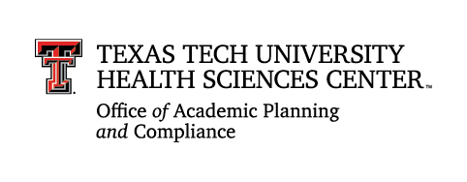
TTUHSC Weave Glossary

Continuous Improvement Report

Academic and Student Support Services | A unit type that provides academic or non-academic support to students to enhance learning, development, and overall success.
Action Plan | Demonstrates how the results of the assessment will be used for improvement in the future.
Administrative Support Services | A unit type that provides operational, administrative, or logistical support to the institution’s functions.
Assessment/Continuous Improvement Plan | A collaboratively developed plan that outlines the intended actions and results of a unit, as well as how it will assess the actions and results over time. The plan demonstrates alignment between the unit’s outcomes/objectives with the institution’s mission and goals. This information is due during Phase One of the reporting cycle.
Assessment/Continuous Improvement Report | A report that includes the unit’s assessment plan along with its academic-year-based findings, action plans, and progress on planned improvements. This information is due during Phase Two of the reporting cycle.
Customer Outcome | A statement that reflects the department’s expected results for its intended customer or audience.
Direct Measure | An assessment approach that evaluates actual samples of student or customer performance to determine whether outcomes have been achieved.
Educational Program | An educational program is a coherent course of study leading to a for-credit credential, including a degree, diploma, certificate, or other generally recognized credential.
Findings | The documented results of assessment activities, showing the extent to which outcomes or objectives have been met.
TTUHSC Goal/Guideline | One of six Strategic Guidelines laid out in the 2026–2030 TTUHSC Strategic Plan.
Indirect Measure | An assessment approach that uses perceptions, reflections, or self-reports rather than direct demonstration of achievement.
Measures/Metrics | A clearly defined value or indicator that explains what is being measured to demonstrate progress toward an outcome or objective. Measures are concise, aligned with outcomes, and may include assessment activities and tools used to obtain or analyze data points.
Unit Mission Statement | A brief statement of the general values and principles that guide the program’s curriculum or the department’s goals.
Outcomes/Objectives | Statements identifying the intended results from program or department actions. This term refers to student learning outcomes, customer outcomes, or process objectives.
Process Objective | A statement that reflects an anticipated action designed to move the department toward accomplishing its mission.
Progress on Planned Improvements | Demonstrates how results were used for improvement in the previous academic year.
Student Learning Outcome | A measurable statement regarding student attainment of knowledge, skills, values, or attitudes.
Targets | Specific criteria for success in achieving an outcome/objective; targets can include directional goals or quantifiable benchmarks.
Unit | Division, department, program, or office. Referred to as “Projects” in Weave.

References: SACSCOC Resource Manual

